**Progress Report No. 1**

Web Systems and Technologies

( Final Project )

|  |  |  |
| --- | --- | --- |
| **Project Title:** | Course Website | |
| **Date of Submission:** | April 27, 2018 | |
| **Class Code & Schedule:** | 9331A 3:00 – 4:00 pm TF | |
| **Project Manager** | Ryan Christian De Guzman |  |
| **Members:** | Francheska Derije |  |
| Ivy Mae Palma |  |
| Ceasar Jim Romero |  |
| Daren Sison |  |

**Task Assigned**:

Documentation: **Ryan, Ivy, Frnachesca**

Front end: **Caesar, Ryan**

Back End: **Caesar, Daren, Ryan**

Lectures / Content: **Everyone**

Week 1:

|  |  |
| --- | --- |
| **Accomplished Task** | **To be Accomplish** |
| 1. Design and structure of the Course Website. 2. Technologies to be used in developing the Course Website. 3. Distribution of task. 4. Contents of the Course Website. | 1. The contents must be integrated to the webpages. 2. Improved the Course website design making it interactive and add some multimedia. 3. Some of the functions are already integrated to the Course Website. |

**Technologies to be used**:

Scripting Languages:

* PHP
* JavaScript
* HTML/CSS

Framework:

* + - Bootstrap

### About the Project

The team decided to create an a website for the subject, Web Systems and Technologies where students can learn new topics and test their knowledge and skills when it comes to web development. The website also includes an online quizzer which contains different tests such as identification, coding and multiple choice. Each tests contains ten questions for a student to answer.

### Project Related Issues

Below are the list of some of the possible issues or problems that the team might encounter while developing the project:

* How will the online quizzer be accessed by the users?
* What are the different topics to be put on the website?
* How many users can the website and the online quizzer accommodate?
* Will the online quizzer produce an accurate result in checking the answers?
* Will the online quizzer be responsive that even a mobile phone can access it?
* Will the website resists unauthorized users?

**Output Screenshots**:



***Figure 1 Homepage of the Website***

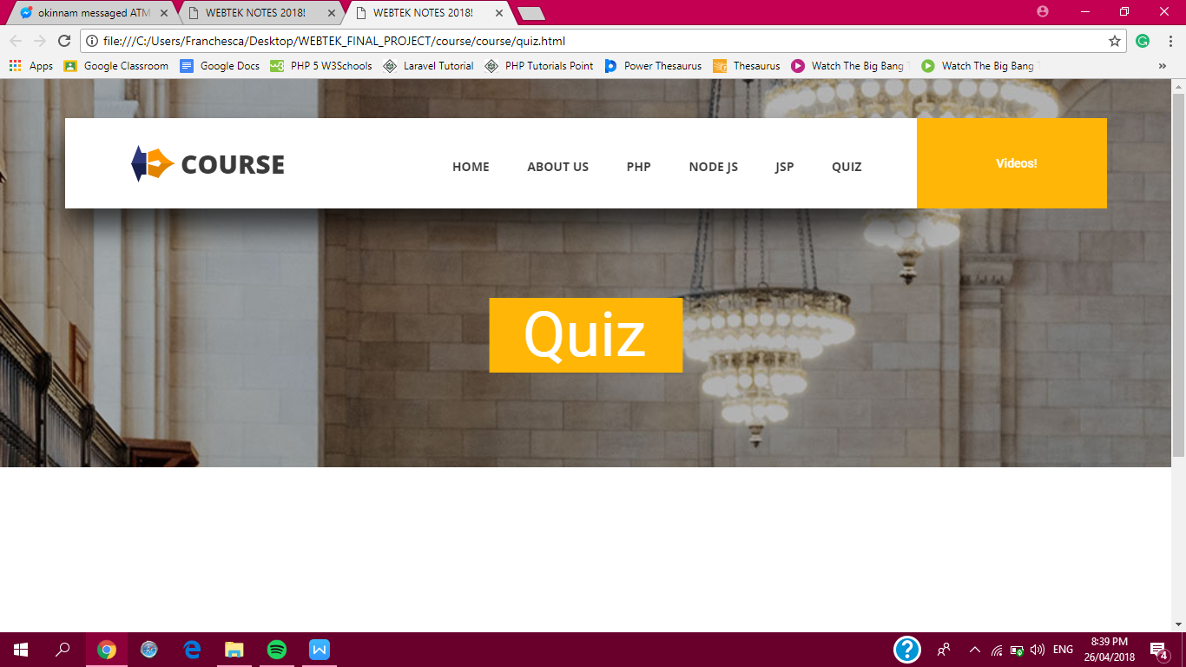

***Figure 2 Quiz page of the Website***



***Figure 3 About Us page of the Website***



***Figure 4 Introduction about the Website***

**Project Meeting**

Conference Call – April 26, 2018

Members involved: Ryan, Caesar, Ivy

